Automated Attendance Portal using RFID

and Face Recognition

**1.Prof. Anmol Jain 2. Anand Parashar 3. Antriksh Tyagi 4.  Devraj Gupta 5. Ansh Srivastava**

***Department of Computer Science, KIET GROUP OF INSTITUTIONS, Ghaziabad***

[**1.anmol.jain@kiet.edu**](mailto:1.anmol.jain@kiet.edu)

[**2.anand.2024cs1105@kiet.edu**](mailto:2.anand.2024cs1105@kiet.edu)

[**3.antriksh.2024cs1203@kiet.edu**](mailto:3.antriksh.2024cs1203@kiet.edu)

[**4.dev.2024cs1025@kiet.edu**](mailto:4.dev.2024cs1025@kiet.edu)

[**5.ansh.2024cs1162@kiet.edu**](mailto:5.ansh.2024cs1162@kiet.edu)

**Abstract:**

**The management of the attendance can be a great burden on the teachers if it is done by hand. To resolve this problem, smart and auto attendance management system is being utilized. But authentication is an important issue in this system. The smart attendance system is generally executed with the help of biometrics. Face recognition is one of the biometric methods to improve this system. Being a prime feature of biometric verification, facial recognition is being used enormously in several such applications, like video monitoring and CCTV footage system, an interaction between computer & humans and access systems presents indoors and network security. By utilizing this framework, the problem of proxies and students being marked present even though they are not physically present can easily be solved. The main implementation steps used in this type of system are face detection and recognizing the detected face.**

**Automatic face recognition (AFR) technologies have made many improvements in the changing world. Smart Attendance using Real-Time Face Recognition is a real-world solution which comes with day-to-day activities of handling student attendance system.**

**Face recognition-based attendance system is a process of recognizing the students face for taking attendance by using face biometrics based on high - definition monitor video and other information technology.**

**It helps in conversion of the frames of the video into images so that the face of the student can be easily recognized for their attendance so that the attendance database can be easily reflected automatically.**

**This paper proposes a model for implementing an automated attendance management system for students of a class by making use of face recognition technique, by using Eigenface values, Principle Component Analysis (PCA) and Local Binary Patterns Histograms (LBPH) algorithm. After these, the connection of recognized faces ought to be conceivable by comparing with the database containing student's faces. This model will be a successful technique to manage the attendance and records of students.**

**I-Introduction**

To verify the student attendance record, the personnel staff ought to have an appropriate system for approving and maintaining the attendance record consistently. By and large, there are two kinds of student attendance framework, i.e. Manual Attendance System (MAS) and Automated Attendance System (AAS). Practically in MAS, the staff may experience difficulty in both approving and keeping up every student's record in a classroom all the time [1]. In a classroom with a high teacher-to-student ratio, it turns into an extremely dreary and tedious process to mark the attendance physically and cumulative attendance of each student. Consequently, we can execute a viable framework which will mark the attendance of students automatically via face recognition. AAS may decrease the managerial work of its staff. Especially, for an attendance system which embraces Human Face Recognition (HFR), it normally includes the students' facial images captured at the time he/she is entering the classroom, or when everyone is seated in the classroom to mark the attendance [1].

Generally, there are two known methodologies to deal with HFR, one is the feature-based methodology, and the other is the brightness-based methodology. The featurebased methodology utilizes key point features present on the face, called landmarks, of the face, for example, eyes, nose, mouth, edges, or some other unique attributes, as shown in fig.1. In this way, out of the picture that has been extricated beforehand, just some part is covered during the calculation process. Then again, the brightness-based methodology consolidates and computes all parts of the given picture [1]. It is also called holistic-based or image-based methodology. Since the overall picture must be considered, the brightnessbased methodology takes longer handling time and is likewise more complicated [1].

In surveillance systems brightness based approaches are commonly used .In this paper we used LBPH(Local binary pattern Histograms) .LBPH is a widely used technique for face recognition due to its simplicity and effectiveness, especially for recognizing faces in images or video streams with varying lighting conditions. It works by comparing the local texture patterns of the face regions in the input images. These patterns are represented as histograms and used to train a recognizer model. During recognition, the algorithm compares the histogram of the input face image with the histograms of the faces in the training set to identify the closest match.

We also propose a robust and easily scalable website which can manage the no. of students with their image folder ,teachers with time table ,identification of teacher using their RFID cards /Unique RFID numbers.

The website is developed from PHP and MY SQL tech stack and this serves as the backend tech of our website.it has various scripts/modules which retrieves class information such as class name ,subject, teacher details based on their RFID tags.

**Literature Survey**

Face recognition technology has gained significant attention in recent years due to its wide range of applications in security, surveillance, biometrics, and more. Traditional face recognition methods relied on techniques such as Eigenfaces and Fisher faces, which extract global features from facial images. However, these methods had limitations in handling variations in pose, lighting, and expression**.**

The Local Binary Patterns Histograms (LBPH) algorithm has emerged as a robust approach for face recognition. LBPH operates by analysing the local texture patterns of grayscale images, making it resilient to changes in lighting conditions. It extracts texture-based features from facial images, enabling accurate recognition even in challenging environments. LBPH has been widely adopted in various applications due to its simplicity, effectiveness, and computational efficiency.

Integrating face recognition technology with a PHP-based backend offers a scalable and flexible solution for attendance management systems. PHP provides a versatile platform for web development, allowing seamless integration with face recognition algorithms implemented in Python. This integration enables real-time attendance tracking, data management, and reporting through a user-friendly web interface. However, it requires careful consideration of security measures and system architecture to ensure reliable operation and data privacy.

Numerous research studies and projects have explored attendance management systems using various technologies, including face recognition, RFID, biometric authentication, and mobile applications. Each approach has its advantages and limitations, with face recognition systems offering the benefits of non-intrusive identification and automation. However, challenges such as accuracy, scalability, and ethical considerations need to be addressed to deploy face recognition-based attendance systems effectively.

Several case studies and real-world applications demonstrate the effectiveness of integrating face recognition with PHP-based backend systems for attendance management. For example, a university might deploy such a system to automate attendance tracking in classrooms, streamline administrative tasks, and improve overall efficiency. By leveraging face recognition technology, these systems offer enhanced accuracy, convenience, and accountability compared to traditional methods.

**Objectives**

As we aim to build an automated attendance portal which is on web version to automate the attendance through face recognition. Objectives are as follows-

1. Develop a Robust Face Recognition System.
2. Integrate Face Recognition with PHP Backend.
3. Automate Attendance Tracking Process
4. Ensure Data Security and Privacy.
5. Provide User-Friendly Interface.
6. Support Scalability and Customization.
7. Facilitate Integration with Existing Systems.
8. Ensure Accessibility and Usability.

**Tools and Technology**

**Python:**

Python is powerful and fast, plays well with others, runs everywhere is friendly and easy to learn. Python source files use the " .py " extension and are called "modules."

There are no type of declaration of variables, parameters, functions, or methods in source code. This makes the code short and flexible, and you lose the compiler-time type checking.

of the source code. Python tracks the types of all values at run time and flags code that does not make sense as it runs.

**a) Features of Python:**

(a). Small Core

(b). Clear, Concise, and Orthogonal Syntax.

(c). Self-Documenting

(d). Easy supports for default arguments (e). True object oriented and 'First Class classes and functions.

(f). Classes are used extensively in the standard library.

(g). Multiple Inheritance

(h). Object-Oriented file handling

(i). Method Chaining

(j). Everything is a reference.

(k). 'Del' statement for all data types

(l). Simple array slicing syntax.

(m). Consistent case sensitivity

(n). Operator overloading

(o). Structured exception handling

(p). Threading

b) **Python Modules Used in Portal** **:**

1)NumPy (for numerical computations and data manipulation in Python.)

2)Datetime (Used for handling date and time-related operations.)

3)Serial (Used for serial communication with external devices, such as RFID readers.)

4)Array (In Python, an array is a data structure that can hold a fixed-size sequence of elements of the same data type.)

**Open CV:**OpenCV (Open-Source Computer Vision Library) is an open-source computer vision and machine learning software library. It provides a wide range of functionalities for image and video processing, including object detection, face recognition, feature detection, image filtering, and more.

**Features Of Open CV-:**

1) Image Processing.

2)Video Processing.

3)Object Detection and Tracking.

4)Feature Detection and Description.

5)Image Filtering and Transformation.

6)Face Recognition and Biometrics.

7)Machine Learning Support.

8)Deep Learning Inference.

9)Graphical User Interface (GUI) Tools.

10)Camera Calibration and 3D Reconstruction.

Overall, OpenCV is a powerful and versatile library that is widely used in research, academia, and industry for a wide range of computer vision tasks and applications.



**PHP:(Hypertext Preprocessor)**

PHP is a versatile and widely used programming language for web development, known for its simplicity, flexibility, and broad ecosystem of tools and resources. It continues to evolve with new features and improvements, making it a popular choice for building dynamic and interactive web applications.

**Features of PHP-:**

1)Server-Side Scripting.

2)Cross-Platform Compatibility.

3)Open Source.

4)Easy to Learn and Use.

5)Integration with Web Servers.

6)Database Connectivity.

7)Extensive Library of Functions.

8)Security Features.

**My SQL:**

MySQL is an open-source relational database management system (RDBMS) that is widely used for building scalable, high-performance web applications. Developed by MySQL AB, which was later acquired by Sun Microsystems (now part of Oracle Corporation), MySQL is known for its reliability, ease of use, and comprehensive feature set.

MySQL is a robust, scalable, and feature-rich database management system that is widely used in web development, e-commerce, content management, social networking, and other applications. Its reliability, performance, and extensive feature set make it a popular choice for building and managing databases in various industries and domains.

**Features of My SQL-:**

1. Relational Database Management System (RDBMS).
2. Open Source.
3. Cross-Platform Compatibility.
4. Scalability and Performance.
5. SQL Support.
6. Replication and High Availability.
7. Backup and Recovery.
8. Security Features.
9. Indexes and Optimization.
10. Concurrency Control.

**Activity Diagram-:**

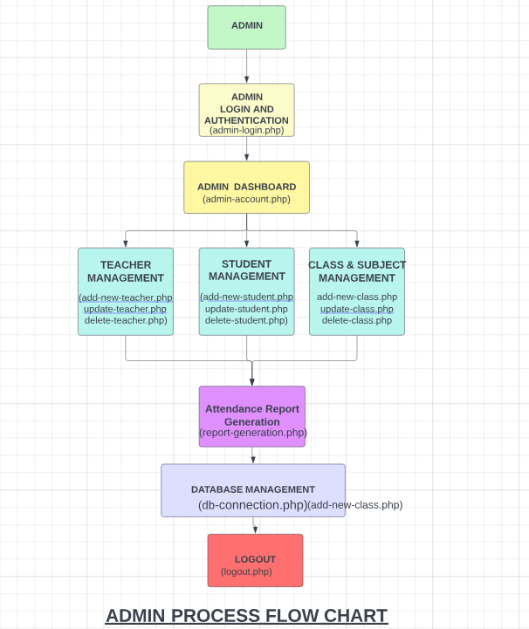

**PROCESS FLOW DIAGRAMS**

**(PFDs’)**

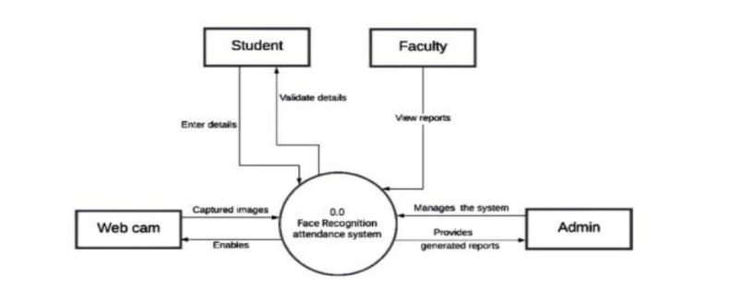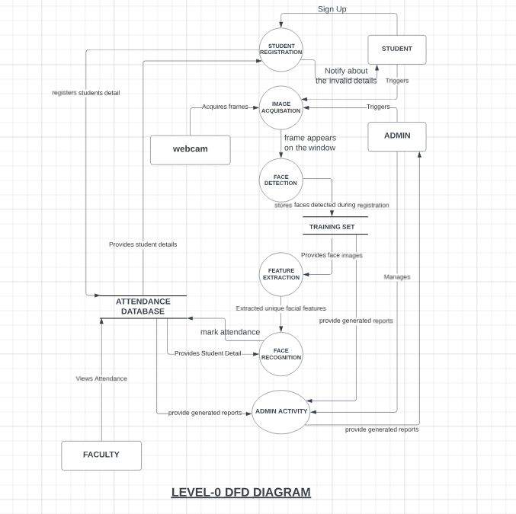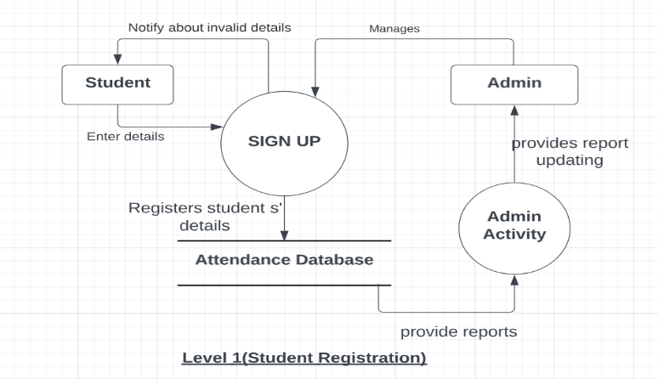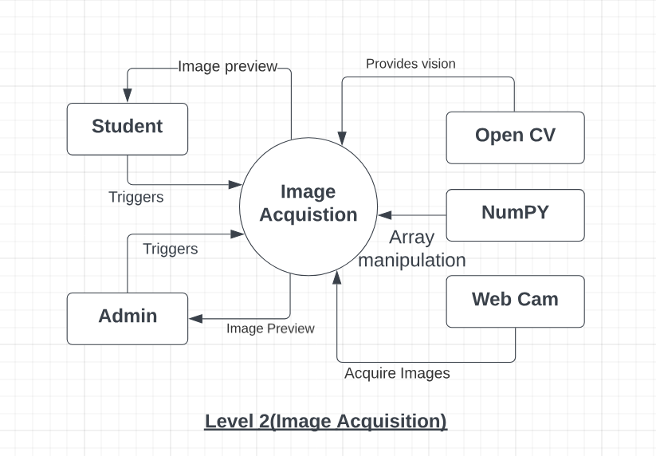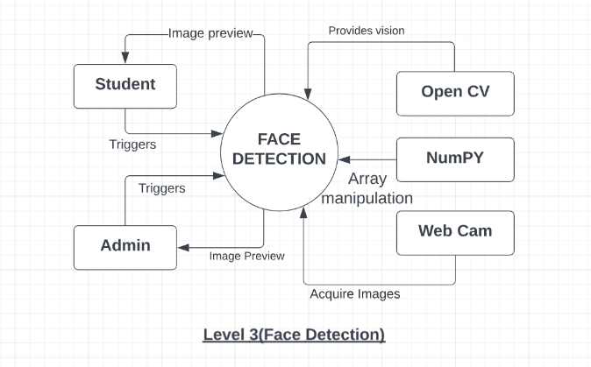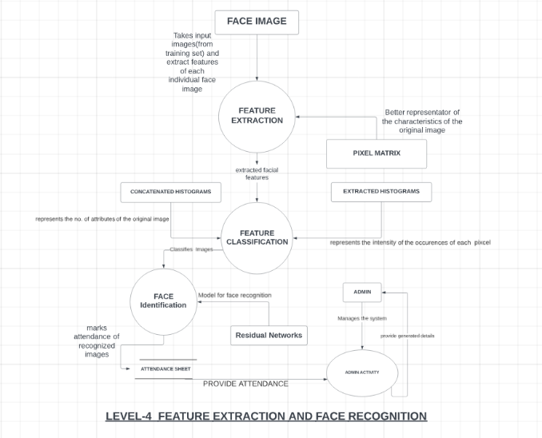

**ALGORITHMS-:**

**Face Description with Multi-scale LBP(LBPH)**

**Basic Uniform Local Binary Patterns**

he LBP operator, shown in Equation 1, a powerful texture measure with a lowcomputational complexity, extracts information which is invariant to local Gray-scale variations of the image. During the LBP operation, the value of current pixel, gc, is applied as a threshold to each of the neighbours, gap(p=0,….P-1) to obtain a binary Multi-scale Local Binary Pattern Histograms for Face Recognition 811 number. A local binary pattern is obtained by first concatenating these binary numbers and then converting the sequence into the decimal number. Using circular neighbourhoods and linearly interpolating the pixel values allows the choice of any radius, R, and number of pixels in the neighbourhood, P, to form an operator.

A subset of these 2P binary patterns, called uniform patterns, can be used to represent spot, flat area, edge and corner. The uniformity measure, U(x), presented in Equation 2 records the number of spatial transitions in the binary pattern, and the uniform pattern is a binary pattern which contains at most two bitwise transitions, i.e., U(x)≤2. The uniform pattern contains in total (P-1)P+2 binary patterns. It consists of two types of patterns, namely (P-1)P rotational patterns, such as edges and two non-rotational patterns, such as a bright spot or a flat area. Other patterns, where U(x)>2, are regarded as non-uniform patterns. The uniform LBP operator, LBPu2P,R, is defined as.

Superscript u2 shown in Equation 2 indicates that the definition relates to uniform patterns with a U value of at most 2. If U(x) is smaller than 2, the current pixel will be labelled by an index function, I(z). Otherwise, it will be labelled as (P-1)P+2. The index function, I(z), containing (P-1)P+2 indices, is used to assign a particular index to each of the uniform patterns. Some researchers used the LBP operator as one of the face normalization techniques [1] and then directly applied a LDA classifier to the LBP image. However, such an approach will fail in the presence of an image translation or even rotation. The histogram approach which first summarizes the LBP image statistically has been proposed to alleviate these problems. As keeping the information about the spatial relation of facial regions is very important for face recognition, the face image is first divided into several small non-overlapping regions of the same size. Uniform pattern histograms are computed over the regions and then concatenated into a single histogram representing the face image.

**Multi-scale Local Binary Patterns**

By varying the sampling radius, R and combining the LBP images, a multiresolution representation based on LBP, called multi-scale local binary patterns [10] can be obtained. This representation has been suggested for texture classification and the results reported for this application show that its accuracy is better than that of the single scale local binary pattern method. In general, this multiresolution representation can be realized in two ways. First, it can be accomplished by increasing the neighbourhood size of the operator. Alternatively one can down-sample the original image with interpolation or low-pass filtering and then apply an LBP operator of fixed radius. However, the general problem associated with the multiresolution analysis is the high dimensionality of the representation combined with the small training sample size. It limits the total number of LBP operators to at most of 3. One of the approaches [13] is to employ a feature selection technique to minimize redundant information. We propose another method which achieves dimensionality reduction by feature extraction.

As expected for the LBP histogram based methods, the mean recognition rate is reduced as the window size increases because of the loss of the spatial information, but for our method, the mean recognition rate is robust for a wide range of 16≥k>3.

Face recognition is essentially the task of identifying a person based on their facial appearance in computer science. In the past two decades, it has greatly increased in popularity, largely due to new techniques created and the excellent quality of the most recent recordings and cameras. The Local Binary Pattern (LBP) texturing operator labels each pixel in an image by thresholding its immediate surroundings and treating the result as a binary number. Furthermore, it has been discovered that using LBP in conjunction with HOG descriptors significantly enhances detection performance on specific datasets. We can express the images of faces using a straightforward data vector by using the LBP in conjunction with histograms. As LBP is a visual descriptor it can also be used for face recognition tasks, as can be seen in the following step-by step explanation.

1) Parameters: the LBPH uses 4 parameters: · Radius: the radius is used to build the circular local binary pattern and represents the radius around the central pixel. · Neighbours: the number of sample points to build the circular local binary pattern. · Grid X: the number of cells in the horizontal direction. · Grid Y: the number of cells in the vertical direction.

2) Training the Algorithm: We must first train the algorithm. We must use a dataset containing the facial photographs of the persons we wish to identify in order to accomplish this. In order for the algorithm to identify an input image and provide you with a result, we also need to set a Student ID for each image.

3) Applying the LBP operation: The initial computational phase of the LBPH is to produce an intermediate image that, by emphasizing the face features, more accurately describes the original image. The algorithm does this by utilizing a sliding window idea based on the radius and neighbours of the parameter. Suppose we have a facial image in grayscale. We can get part of this image as a window of 3x3 pixels. It can also be represented as a 3x3 matrix containing the intensity of each pixel (0-255). The matrix's central value must then be used as the threshold, which is what we must do next. We establish a new binary value for each neighbour of the threshold value. The matrix will now only have binary values. Each binary value from each point in the matrix must be concatenated, line by line, into a new binary value. The central value of the matrix, which is actually a pixel from the original image, is then set to this binary value after being converted to a decimal value. At the conclusion of this process (the LBP technique), we obtain a new image that more accurately captures the traits of the original image.

4) Extracting the Histograms: As we have an image in grayscale, each histogram (from each grid) will contain only 256 positions (0-255) representing the occurrences of each pixel intensity. Then, we need to concatenate each histogram to create a new and bigger histogram.

5) Performing the face recognition: The algorithm has already been trained at this point. Each histogram produced serves as a representation of one of the training dataset's images. Therefore, given an input image, we repeat the process for the new image and produce a histogram that symbolizes the image. Simply compare two histograms and return the image with the closest histogram to identify the image that matches the input image. The distance between two histograms can be calculated using a variety of methods, such as the Euclidean distance, chi-square, absolute value, etc. So, the algorithm output is the ID from the image with the closest histogram. The algorithm should also return the calculated distance, which can be used as a ‘confidence’ measurement. We can then use a threshold and the ‘confidence ‘to automatically estimate if the algorithm has correctly recognized the image. We can assume that the algorithm has successfully recognized if the confidence is lower than the threshold defined.

**B) HCC A(Haar cascade classifier)**

Haar classifier, or a Haar cascade classifier, is a machine learning object detection program that identifies objects in an image and video. The algorithm can be explained in four stages:

• Calculating Haar Features

• Creating Integral Images

• Using Adaboost

• Implementing Cascading Classifiers

It’s important to remember that this algorithm requires a lot of positive images of faces and negative images of non-faces to train the classifier, similar to other machine learning models.

1) **Calculating Haar Features:** Gathering the Haar features is the initial stage. In a detection window, a Haar feature is effectively the result of calculations on adjacent rectangular sections. In order to calculate the difference between the sums, the pixel intensities in each region must first be added together. Identifying these elements in a large photograph can be challenging. This is where integral images come into play because the number of operations is reduced using the integral image.

**2) Creating Integral Images:** Without going into too much of the mathematics behind it, integral images essentially speed up the calculation of these Haar features. Instead of computing at every pixel, it instead creates sub-rectangles and creates array references for each of those sub-rectangles. These are then used to compute the Haar features.

**3) AdaBoost Training:** In essence, Adaboost selects the top features and trains the classifiers to use them. The algorithm can detect objects by using a "strong classifier" that is made by combining several "weak classifiers." By sliding a window across the input image and computing Haar characteristics for each area of the image, weak learners are produced. This distinction is contrasted with a learnt threshold that distinguishes between non-objects and objects. Since these are "weak classifiers," creating a strong classifier requires a lot of Haar features to be accurate.

**4) Implementing Cascading Classifiers:** Each level of the cascade classifier is made up of weak learners. It consists of a sequence of phases. A highly accurate classifier can be created from the mean prediction of all weak learners by employing boosting during the training of weak learners. The classifier either chooses to go on to the subsequent region (negative) or decides to indicate that an object was identified (positive) based on this prediction. Stages are made to reject negative samples as quickly as possible because the bulk of the windows don't contain anything of interest.

**Result and discussion**

This project deals with the web development and as well as face recognition. The results and discussion of the attendance management system project can be divided into several key aspects:

1. **Efficiency**: The system significantly improves the efficiency of the attendance tracking process compared to manual methods. By leveraging technology such as RFID scanning and online forms, teachers can quickly record attendance without the need for manual entry. This saves time and reduces errors associated with traditional paper-based methods.
2. **Accuracy**: The use of automated data capture methods ensures a higher level of accuracy in attendance records. RFID scanning and biometric recognition technologies provide reliable identification of students, minimizing the risk of errors or discrepancies in attendance data.
3. **Real-time Monitoring**: The system enables real-time monitoring of attendance status, allowing educators and administrators to promptly identify and address attendance issues. By accessing up-to-date attendance reports and analytics, stakeholders can make informed decisions to improve student engagement and academic performance.
4. **Communication and Accountability**: The system facilitates better communication between teachers, students, and parents regarding attendance matters. Automated notifications can be sent to parents or guardians for absences, promoting accountability and encouraging students to attend classes regularly.
5. **Data Analysis**: Comprehensive reporting and analytics tools allow for in-depth analysis of attendance trends and patterns. Educators can identify patterns of absenteeism or tardiness and implement targeted interventions to support students at risk of falling behind academically.
6. **Scalability and Flexibility**: The system is designed to be scalable and adaptable to the needs of different educational institutions. Whether it's a small school or a large university, the system can be customized to accommodate various class sizes, schedules, and attendance policies.
7. **Data Security and Privacy**: Robust data security measures ensure the confidentiality and integrity of attendance records. Access controls and encryption techniques protect sensitive information from unauthorized access or tampering, maintaining compliance with privacy regulations.
8. **User Satisfaction**: Feedback from users, including teachers, administrators, and students, can provide valuable insights into the system's usability and effectiveness. Continuous evaluation and improvement based on user feedback ensure that the system meets the needs and expectations of its stakeholders.

Overall, the attendance management system offers a comprehensive solution to address the challenges associated with manual attendance tracking methods. By leveraging technology, automation, and data analysis, the system enhances efficiency, accuracy, communication, and accountability in managing student attendance, ultimately contributing to improved educational outcomes.

The users can interact with the system using a GUI. Here, users will be mainly provided with three different options such as, student registration, faculty registration, and mark attendance.

• The students are supposed to enter all the required details in the student registration form. After clicking on the register button, the webcam starts automatically.

• The webcam will capture 50 images in-order to create the image dataset and then terminate automatically.

• At the time of forming the image dataset, each student will get designated using an id number. While recognition, when the test student image matches with the dataset then the details of the student in the attendance excel sheet will be marked with a time-stamp, if the test student image does not get matched with the dataset, then it will not be marked present and all the unmatched student will be marked as absent after a certain period of time.

The following Images shows the nature of the system when it is fed with different size of datasets. Here we compare 3 groups of 2 data. Fig-8 depicts the comparison between recognition rate of the system with different camera angles. Fig-9 depicts the comparison between the training time and the number of images in the data set. And, finally, Fig-10 compares the recognition time it takes the system to recognize n number of faces.

For Left view, between,0 and 45 degrees the recognition rate is 99-100 percent. After 45 degrees the rate starts decreasing and goes to zero at 90 degrees angles. For Right view, between,0 and 45 degrees the recognition rate is 97-100 percent. After 45 degrees the rate starts decreasing and goes to zero at 90 degrees angles. And, for 0 degrees, the recognition rate is 100 percent.

the training period to train 10 images is 0.6 seconds, 50 images is 1.69 seconds, 100 images is 2.71 seconds and 150 images is 3.67 seconds. The recognition time for a single

face is 1.1 seconds. Similarly, the recognition time for 3and 7 images is 1.4 and 1.8 seconds respectively. and the recognition time for 10 faces is approximately 2 seconds.

**CONCLUSION**

In conclusion, the attendance management system presented in this project offers a modern and efficient solution to the age-old challenge of tracking student attendance in educational institutions. By leveraging technology such as RFID scanning, biometric recognition, and online forms, the system streamlines the process of recording and monitoring attendance, saving time and reducing errors associated with manual methods.

Overall, the attendance management system represents a significant advancement in attendance tracking methods, offering a comprehensive solution that enhances efficiency, accuracy, communication, and accountability in managing student attendance. As educational institutions continue to embrace technology to improve administrative processes, systems like this will play an increasingly vital role in supporting student success and academic achievement.

In this system, an attendance system is implemented for a lecture, section or laboratory by which the lecturer or teacher can record students’ attendance. It saves time and effort, especially if there are a lot of pupils in the lecture. The goal of the automated attendance system is to minimize the shortcomings of the conventional (manual) approach. The application of image processing techniques in the classroom is demonstrated through this attendance system. This technique can enhance an institution's reputation in addition to simply assisting with the attendance system. The study also aims to highlight the project's enormous potential in the field of machine learning.

• The bad lighting in the classroom can occasionally have an impact on image quality, which negatively impacts system performance. This can be remedied in the latter stages by enhancing the video quality or employing algorithms.

• Advanced processors can be used to improve processing time of images

• GSM can be used to send attendance details of student to their respective parents

• The GUI can be made more interactive by allowing students to check their attendance details with necessary limitations.

**References-:**

1. Heusch, G., Rodriguez, Y., Marcel, S.: Local Binary Patterns as an Image Preprocessing for Face Authentication. In: Proc FGR 2006, pp. 9–14 (2006)

2. Zhang, G., Huang, Z., Li, S.Z.: Boosting local binary pattern (LBP)-based face recognition. In: SinoBiometrics 2004, pp. 179–186 (2004)

3. Beveridge, J.R., Bolme, D., Teixeira, M., Draper, B.: The CSU Face Identification Evaluation System User’s Guide: Version 5.0, Technical Report, C.S. Dept., CSU (2003)

4. Messer, K., Matas, J., Kittler, J., Jonsson, K.: XM2VTSDB: The extended M2VTS database. In: Akumuri, S., Kullman, C. (eds.) AVBPA’99, pp. 72–77 (1999)

5. Messor, K., Kittler, J., Short, J., Heusch, G., Cardinaux, F., Marcel, S., Rodriguez, Y., Shan, S., Su, Y., Gao, W., Chen, X.: Performance Characterisation of Face Recognition Algorithms and Their Sensitivity to Severe Illumination Changes. In: ICB2006, pp. 1–11 (2006)

6. Philips, P.J., Moon, H.J., Rizvi, S.A., Rauss, P.J.: The FERET Evaluation Methodology for Face Recognition Algorithms. PAMI 22(10), 1090–1104 (2000)

7. Belhumeur, P.N., Hespanha, J.P., Kriegman, D.J.: Eigenfaces vs. Fisherfaces: Recognition using Class Specific Linear Projection. In: Buxton, B.F., Cipolla, R. (eds.) ECCV 1996. LNCS, vol. 1065, pp. 45–56. Springer, Heidelberg (1996)

8. Shan, S., Zhang, W., Su, Y., Xhen, X., Gao, W.: Ensemble of Piecewise FDA based on Spatial Histogram of Local (Gabor) Binary Patterns for Face Recognition. In: ICPR (2006)

9. Ahonen, T., Hadid, A., Pietikäinen, M.: Face description with local binary patterns: Application to face recognition. PAMI 28(12), 2037–2041 (2006)

10. Ojala, T., Pietikäinen, M., Mäenpää, T.: Multiresolution Gray-Scale and Rotation Invariant Texture Classification with Local Binary Patterns. PAMI 24(7), 971–987 (2002)

11. Zhang, W., Shan, S., Zhang, H., Gao, W., Chen, X.: Multi-resolution histogram of local variation patterns (MHLVP) for Robust Face Recognition. In: Kanade, T., Jain, A., Ratha, N.K. (eds.) AVBPA 2005. LNCS, vol. 3546, pp. 937–944. Springer, Heidelberg (2005)

12. Huang, X., Li, S.Z., Wang, Y.: Jensen-Shannon Boosting Learning for Object recognition. In: Proceeding of CVPR (2005)

13. Raja, Y., Gong, S.: Sparse Multiscale Local Binary Patterns. In: Proc. 17thBMVC (2006)

14. Rodriguez, Y., Marcel, S.: Face authentication using adapted local binary pattern histogram. In: Leonardis, A., Bischof, H., Pinz, A. (eds.) ECCV 2006. LNCS, vol. 3954, pp. 321–332. Springer, Heidelberg (2006).

15. Shreyak Sawhney, Karan Kacker, Samyak Jain, Shailendra Narayan Singh , Rakesh Garg, “Real-Time Smart Attendance System using Face Recognition Techniques”, 2020

[2] Naman Gupta, Purushottam Sharma, Vikas Deep, Vinod Kumar Shukla, “Automated Attendance System Using OpenCV”, 2019

16. Krishna Mridha, Nabhan Tawjih Yousef, “Study and Analysis of Im- plementing a Smart Attendance Management System Based on Face Recognition Technique using OpenCV and Machine Learning”, 2021

17.Organization, S. D. I. W. C., Kuster, B. (2018). Face Detection and Face Recognition in Python Programming Language. The Seventh International Conference on Informatics and Applications (ICIA2018).

18.Emami, Shervin Suciu, Valentin. (2012). Facial Recognition using OpenCV. Journal of Mobile, Embedded and Distributed Systems.